**DATA VISUALIZATION ASSIGNMENT #3**

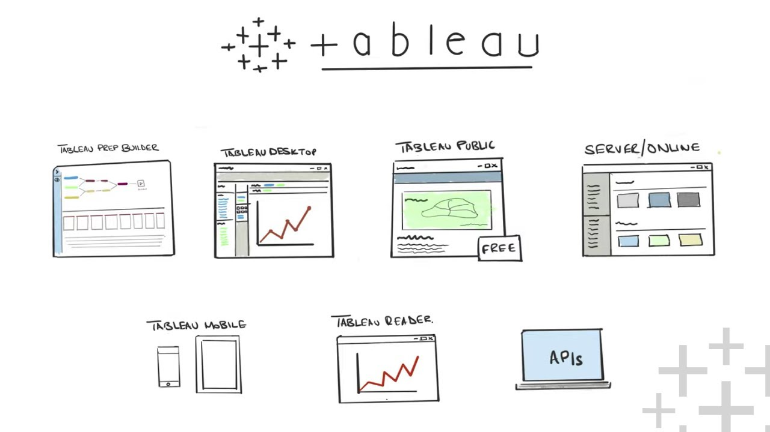

[This Photo](https://www.tableautim.com/playlist/tableau-explained?93997e09_page=2) by Unknown Author is licensed under [CC BY-NC-ND](https://creativecommons.org/licenses/by-nc-nd/3.0/)

Kim, Suchul - 300362625

Haridas, Sudarsan - 300353099

Douglas College

CSIS 3860 - 070, Fall 2023: DATA VISUALIZATION

Professor: Rupa Manabala

Dec 01, 2023

**Analysis questions**

* How might the number of patients visiting the clinic change next month?
* What is the common age range of our clinic's patients?
* Over the past few years, have the number of patient visits been going up or down?
* Which department has patients waiting the longest?
* How long do patients typically spend in appointments in different locations?

**Data Connections**

* **Connecting to Data Sources :** Import data from Clinical Management System.json into tableau.
* **Inspect and Clean Data:** Performs automatic cleaning.

**Sorting and Filtering :** Sorting and Filtering by Average Age of Patients

The data is organized by location and department, with color coding to differentiate between departments like General Medicine, Dermatology, Orthopaedics, Ophthalmology, and Pediatrics. For instance, in Alabama, the average patient age ranges from 41 in Ophthalmology to 55 in General Medicine.

**Map** : The locations with the top 10 most visits recorded.

The states of Arizona, Illinois, Virginia, California, Florida, Texas, and New York are labeled with numbers that presumably reflect the count of visits or a similar metric, with Arizona showing the highest number at 10 and Texas the lowest among the labeled states with 1.

**Creating Calculated Fields** : The average visit duration in each location is plotted along with average appointment duration as reference line for proper resource allocation.

The chart compares the average duration of visits in four departments: General Medicine, Ophthalmology, Orthopaedic, and Pediatrics. General Medicine has the longest average visit duration, marked at 40 minutes, while Ophthalmology has the shortest, at 27 minutes.

* This logic ensures that the visit duration is calculated correctly across hours, without incorrectly adding 60 minutes for visits that don't span two hours

**Table Calculations** : Average wait time and time exceeded after the appointment ended is plotted by department and ranked by average wait times.

* Dermatology has the longest average wait time at about 8.22 minutes, followed by Pediatrics, Orthopaedic, Ophthalmology, and General Medicine.

**Trendlines** : Linear Trendline for number of patients in each month.

The actual patient counts per month are represented by a green line with points, and the linear trendline is shown as a dashed line, with upper and lower confidence bands indicated by additional dashed lines. The graph exhibits fluctuations in the monthly patient count but the trendline suggests a slight upward trajectory over time.

**Visualizing Distributions** : The distribution of patient Age.

The number of patients according to their age does not have a special distribution form. The number of patients generally increases from those in their 40s to 60s, but decreases after the age of 70.

**Forecasting** : Forecasting patient visits for the upcoming months

Patient visits are expected from 2020 to 2023, and by 2024, the average is expected to be about 24, the max is about 33, and the min is about 15.

**Answer your analysis questions through your reports**

How might the number of patients visiting the clinic change next month?

The forecast for patient visits shows an expected average of about 24 visits, with a maximum of around 33 and a minimum of about 15 by 2024. This indicates a potential range for the number of patients visiting next month, assuming a steady trend.

What is the common age range of our clinic's patients?

The distribution of patient ages shows an increase in the number of patients from their 40s to 60s, with a decrease after the age of 70. This suggests that the common age range of the clinic's patients is between 40 and 70 years.

Over the past few years, have the number of patient visits been going up or down?

The trendline analysis indicates a slight upward trajectory over time, despite monthly fluctuations. This suggests that the number of patient visits has been generally increasing.

Which department has patients waiting the longest?

Dermatology has the longest average wait time at about 8.22 minutes, followed by Pediatrics, Orthopaedic, Ophthalmology, and General Medicine. Therefore, the Dermatology department has the longest waiting times for patients.

How long do patients typically spend in appointments in different locations?

The average visit duration varies by department. General Medicine has the longest average duration at 40 minutes, while Ophthalmology has the shortest at 27 minutes. This data indicates the typical time patients spend in appointments across different departments.

**References**

Microsoft Power BI Quick Start Guide – Preferably 3 rd edition- Devin Knight, Mitchell Pearson, Bradley Schacht,, et al – ISBN 9781804613498 – Packt Publishing – eBook available from publisher’s website (<https://www.packtpub.com/product/microsoft-power-biquick-start-guide-second-edition/9781804613498>)

Microsoft Ignite

<https://learn.microsoft.com/en-us/power-bi/>

Tableau Desktop and Web Authoring Help

<https://help.tableau.com/current/pro/desktop/en-us/calculations_tablecalculations.htm>

Learning Tableau 2022 – 5 th Edition by Joshua Milligan ISBN 9781801072328 – Packt Publishing - eBook available from publisher’s website and/or Book store (<https://www.packtpub.com/product/learning-tableau-2022-fifth-edition/9781801072328>)